Same-Shape Components with Different Dimensions

Definition
# Source: AI Source: Provided by: [Data Path: Persons Table -> ID Column: 1, Name_En Column: Motasem Essam] -> From: [ChatGPT] on [7/25/2026]
Same-shape components with different dimensions are composite solids formed by joining two or more components that belong to the same geometric category but have different measurements.
The components share the same general geometric shape, but they differ in one or more dimensions, such as:
- Length.
- Width.
- Height.
- Radius.
- Diameter.
- Base dimensions.
- Slant height.
For example, a composite solid formed by joining three cylinders with different radii or heights belongs to this classification.

Simple Definition
# Source: AI Source: Provided by: [Data Path: Persons Table -> ID Column: 1, Name_En Column: Motasem Essam] -> From: [ChatGPT] on [7/25/2026]
A composite solid made from components that have the same geometric shape but different sizes.
For example, joining a small cube, a medium cube, and a large cube creates a composite solid with same-shape components of different dimensions.

Geometric Representation
# Source: AI Source: Provided by: [Data Path: Persons Table -> ID Column: 1, Name_En Column: Motasem Essam] -> From: [ChatGPT] on [7/25/2026]
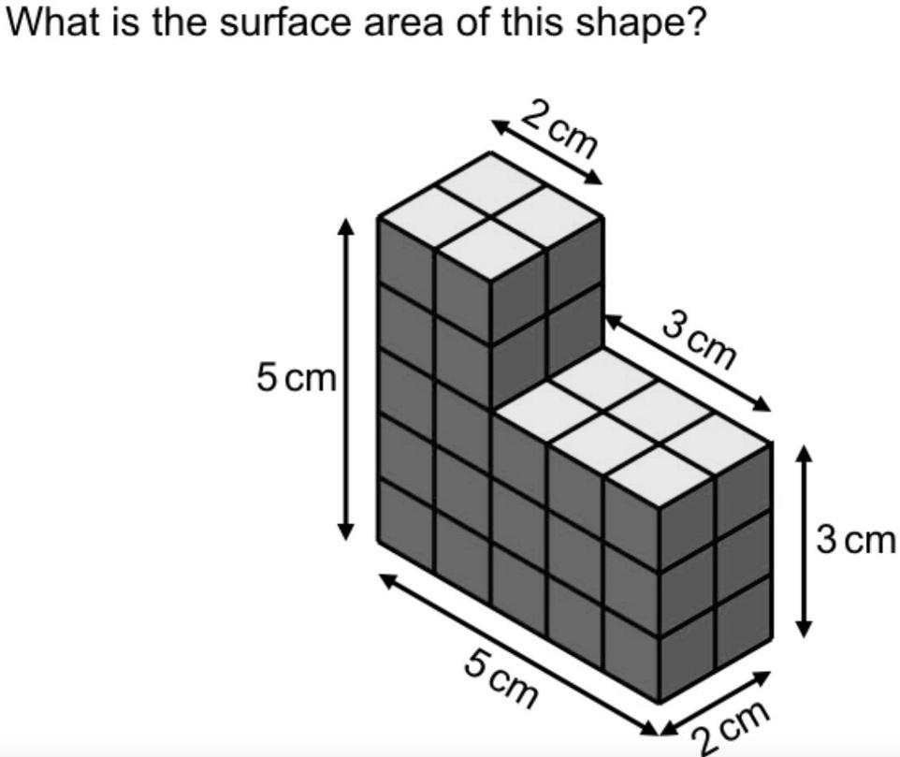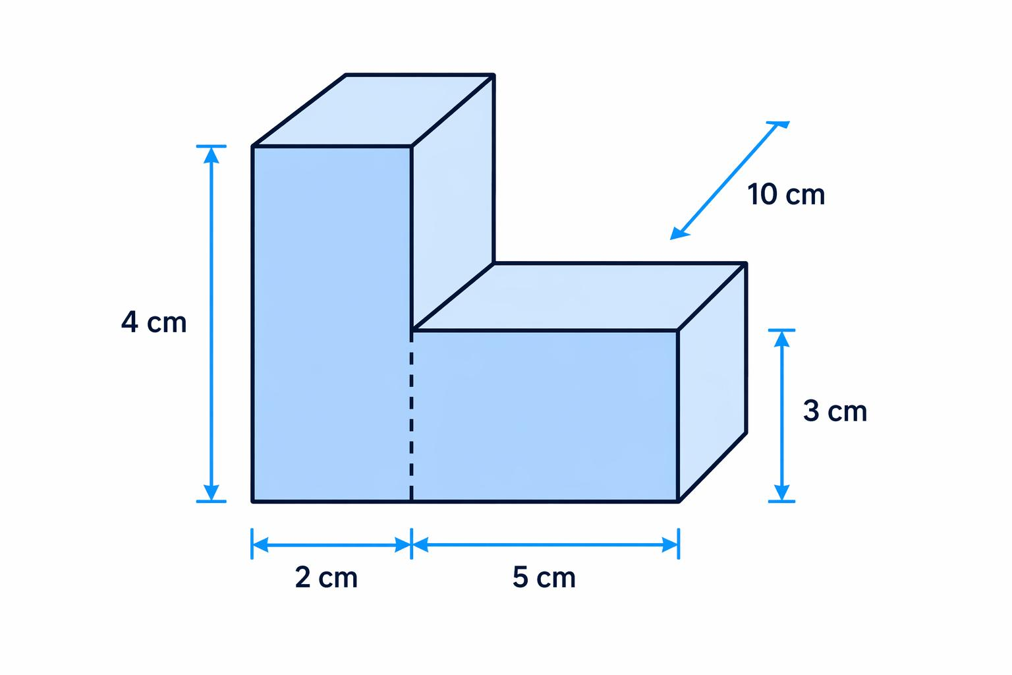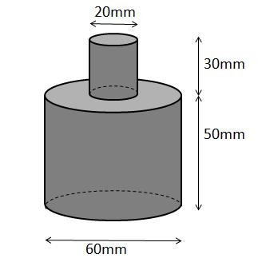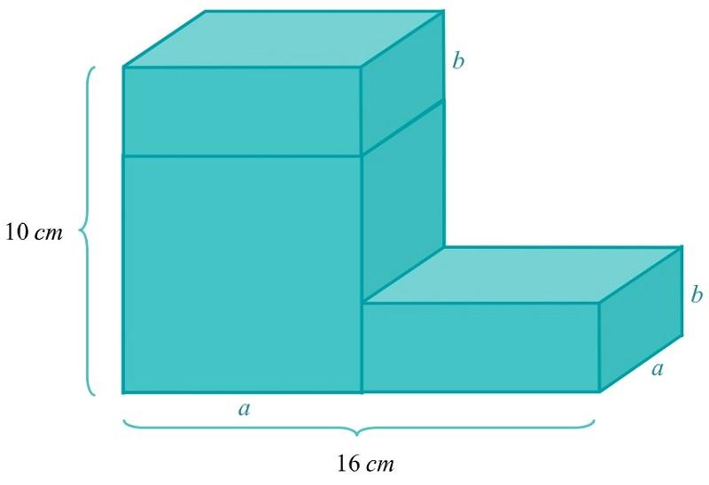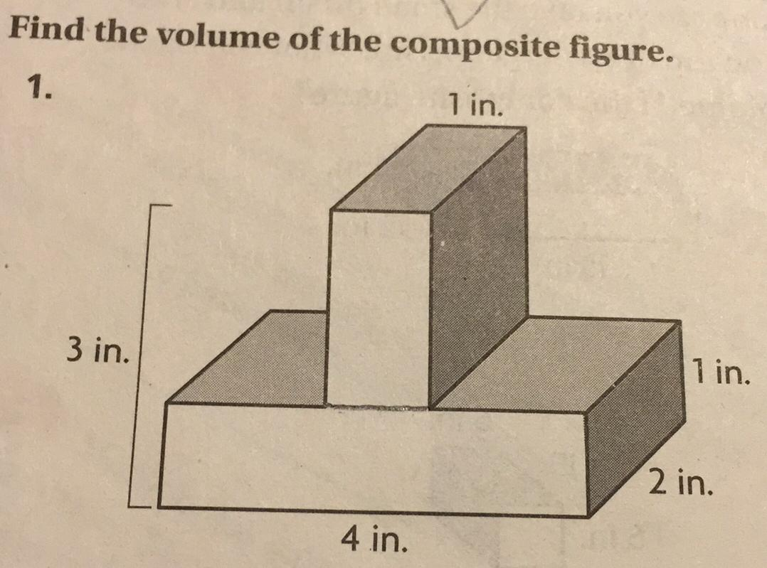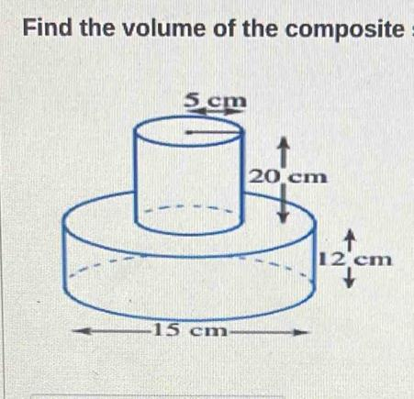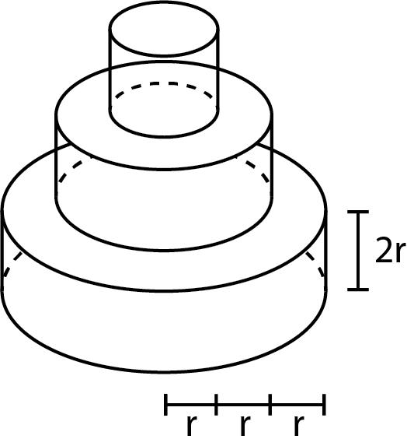
These examples show how components can retain the same geometric shape while varying in size.

Main Classification
# Source: AI Source: Provided by: [Data Path: Persons Table -> ID Column: 1, Name_En Column: Motasem Essam] -> From: [ChatGPT] on [7/25/2026]
Same-shape components with different dimensions can be classified according to the geometric shape shared by their components.

Cube-Based Components with Different Dimensions
# Source: AI Source: Provided by: [Data Path: Persons Table -> ID Column: 1, Name_En Column: Motasem Essam] -> From: [ChatGPT] on [7/25/2026]
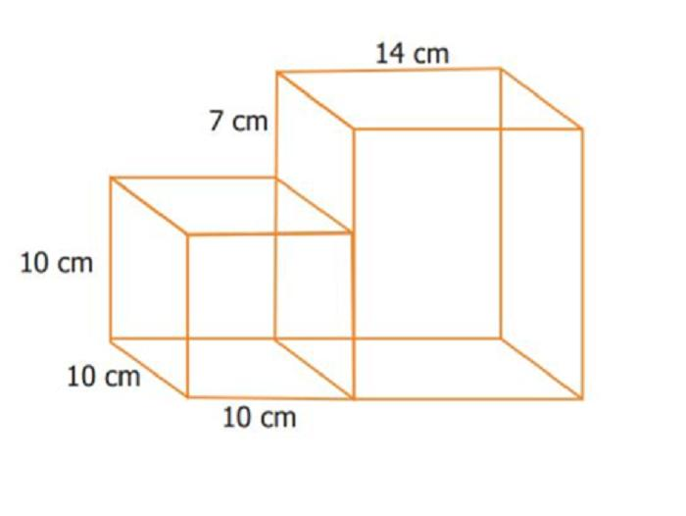
- Every component is a cube.
- Each cube has equal edges within itself.
- The side lengths differ between components.
- The individual cubes have different volumes and surface areas.
For cube $i$, with side length $s_{i}$:
$$V_{i}=s_{i}^{3}$$
$${SA}_{i}=6s_{i}^{2}$$

Rectangular Prism-Based Components with Different Dimensions
# Source: AI Source: Provided by: [Data Path: Persons Table -> ID Column: 1, Name_En Column: Motasem Essam] -> From: [ChatGPT] on [7/25/2026]
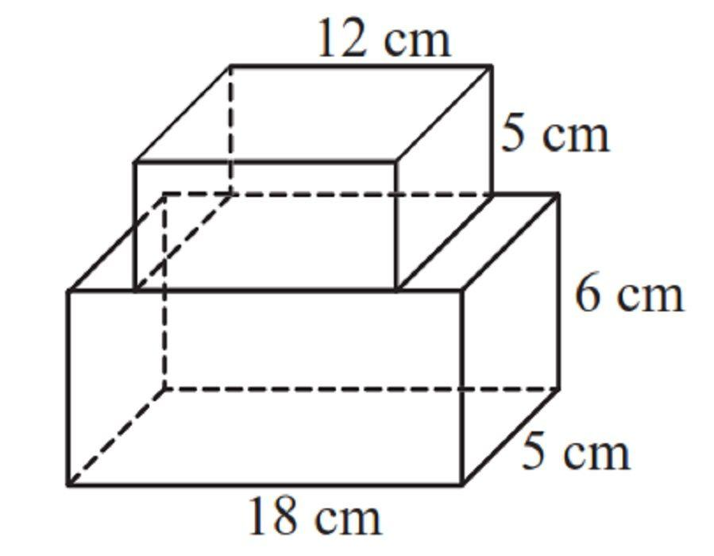
- Every component is a rectangular prism.
- Their lengths, widths, and heights may differ.
- Some dimensions may be equal while others vary.
- Components may be joined through matching or partially matching faces.
For component $i$:
$$V_{i}=l_{i}$$
$${SA}_{i}=2(l_{i}+l_{i}+w_{i})$$

Cylinder-Based Components with Different Dimensions
# Source: AI Source: Provided by: [Data Path: Persons Table -> ID Column: 1, Name_En Column: Motasem Essam] -> From: [ChatGPT] on [7/25/2026]
- Every component is a cylinder.
- Their radii and heights may differ.
- They may have equal radii but different heights, or equal heights but different radii.
- Their axes may be aligned or differently oriented.
For component $i$:
$$V_{i}=πr_{i}^{2}h_{i}$$
$${SA}_{i}=2πr_{i}(r_{i}+h_{i})$$

Cone-Based Components with Different Dimensions
# Source: AI Source: Provided by: [Data Path: Persons Table -> ID Column: 1, Name_En Column: Motasem Essam] -> From: [ChatGPT] on [7/25/2026]

- Every component is a cone.
- Their base radii and perpendicular heights may differ.
- Their slant heights may also differ.
- Components may be joined through their bases or other contact regions.
For component $i$:
$$V_{i}=\frac{1}{3}πr_{i}^{2}h_{i}$$

Pyramid-Based Components with Different Dimensions
# Source: AI Source: Provided by: [Data Path: Persons Table -> ID Column: 1, Name_En Column: Motasem Essam] -> From: [ChatGPT] on [7/25/2026]
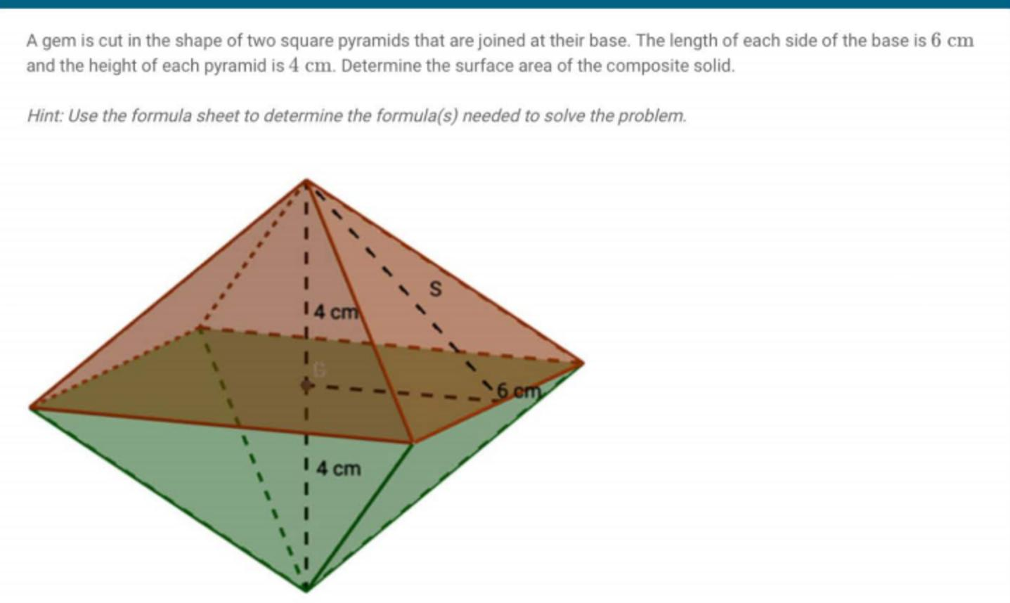
- Every component is a pyramid of the same base shape and general type.
- Their base dimensions and perpendicular heights may differ.
- Their individual volumes and surface areas may vary.
For component $i$:
$$V_{i}=\frac{1}{3}B_{i}$$
Where $B_{i}$ is its base area.

Sphere-Based Components with Different Dimensions
# Source: AI Source: Provided by: [Data Path: Persons Table -> ID Column: 1, Name_En Column: Motasem Essam] -> From: [ChatGPT] on [7/25/2026]
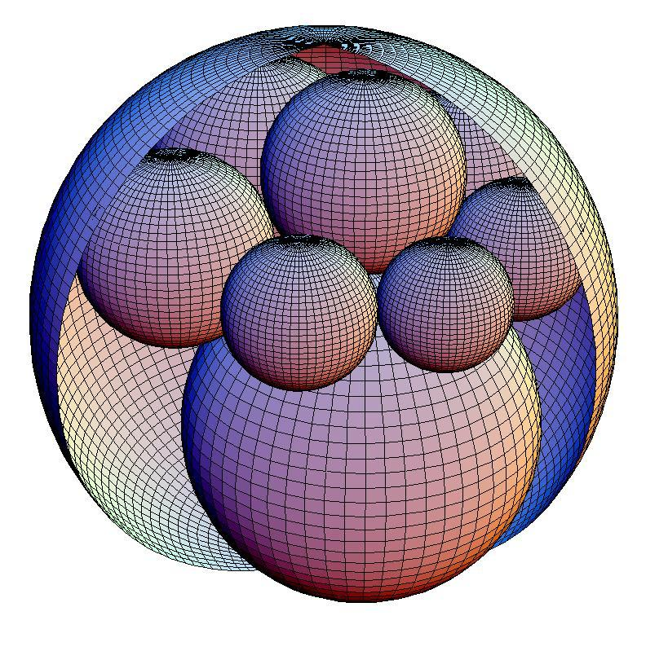
- Every component is a sphere.
- Their radii and diameters differ.
- Each sphere has a different volume and surface area.
For component $i$:
$$V_{i}=\frac{4}{3}πr_{i}^{3}$$
$${SA}_{i}=4πr_{i}^{2}$$

Hemisphere-Based Components with Different Dimensions
# Source: AI Source: Provided by: [Data Path: Persons Table -> ID Column: 1, Name_En Column: Motasem Essam] -> From: [ChatGPT] on [7/25/2026]
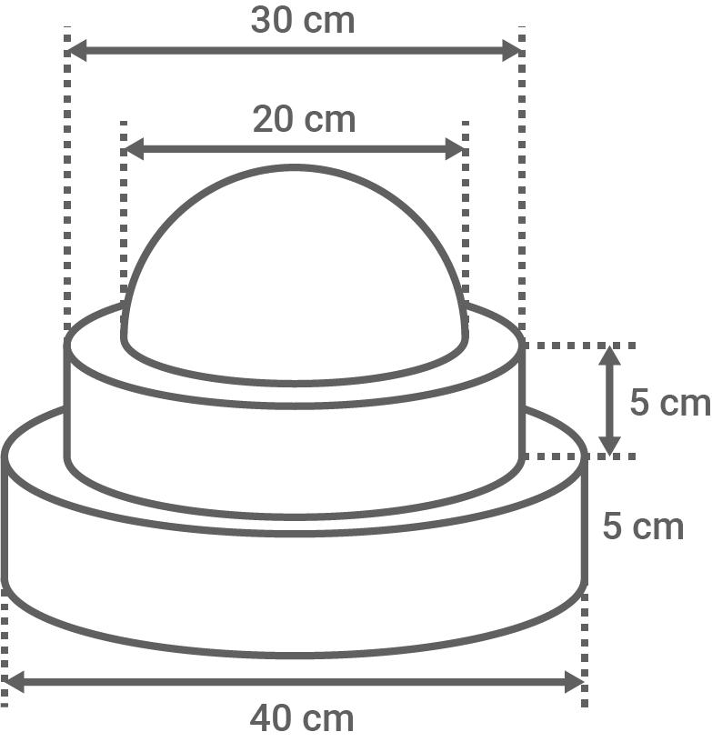
- Every component is a hemisphere.
- Their radii and diameters may differ.
- They may be joined through their flat circular bases or other contact regions.
For component $i$:
$$V_{i}=\frac{2}{3}πr_{i}^{3}$$
$${SA}_{i}=3πr_{i}^{2}$$
The surface area formula includes the curved surface and the flat circular base.

Classification by the Type of Dimensional Variation
# Source: AI Source: Provided by: [Data Path: Persons Table -> ID Column: 1, Name_En Column: Motasem Essam] -> From: [ChatGPT] on [7/25/2026]
The dimensions may differ in several ways.

Different Single Dimensions
# Source: AI Source: Provided by: [Data Path: Persons Table -> ID Column: 1, Name_En Column: Motasem Essam] -> From: [ChatGPT] on [7/25/2026]
Only one corresponding dimension varies while the remaining dimensions are equal.
Examples:
- Cubes with different side lengths.
- Cylinders with different heights but equal radii.
- Spheres with different radii cannot have equal radii, but all retain the same shape.

Different Multiple Dimensions
# Source: AI Source: Provided by: [Data Path: Persons Table -> ID Column: 1, Name_En Column: Motasem Essam] -> From: [ChatGPT] on [7/25/2026]
Two or more corresponding dimensions vary between components.
Examples:
- Rectangular prisms with different lengths and widths.
- Cylinders with different radii and heights.
- Pyramids with different base dimensions and heights.

Proportional Dimensions
# Source: AI Source: Provided by: [Data Path: Persons Table -> ID Column: 1, Name_En Column: Motasem Essam] -> From: [ChatGPT] on [7/25/2026]
Components have different dimensions, but their corresponding measurements maintain the same scale ratio.
For example, two cubes with side lengths 2 cm and 4 cm have a scale factor of 2.
$$k=\frac{s_{2}}{s_{1}}=\frac{4}{2}=2$$

Non-Proportional Dimensions
# Source: AI Source: Provided by: [Data Path: Persons Table -> ID Column: 1, Name_En Column: Motasem Essam] -> From: [ChatGPT] on [7/25/2026]
Components have different dimensions without maintaining one common scale factor across their corresponding measurements.
For example:
- First rectangular prism: $2×3×4$ cm.
- Second rectangular prism: $3×5×6$ cm.
The ratios of corresponding dimensions are not all equal.

Classification by Dimensional Relationship
# Source: AI Source: Provided by: [Data Path: Persons Table -> ID Column: 1, Name_En Column: Motasem Essam] -> From: [ChatGPT] on [7/25/2026]
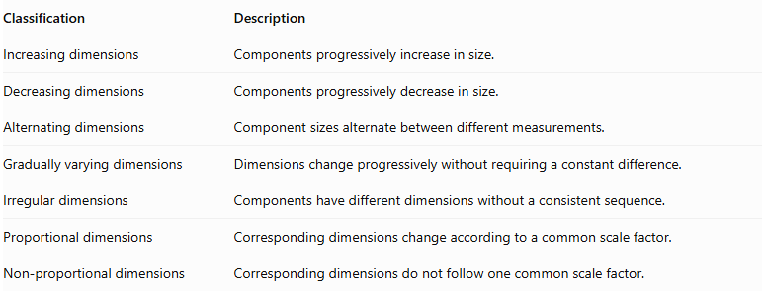
Classification | Description
Increasing dimensions | Components progressively increase in size.
Decreasing dimensions | Components progressively decrease in size.
Alternating dimensions | Component sizes alternate between different measurements.
Gradually varying dimensions | Dimensions change progressively without requiring a constant difference.
Irregular dimensions | Components have different dimensions without a consistent sequence.
Proportional dimensions | Corresponding dimensions change according to a common scale factor.
Non-proportional dimensions | Corresponding dimensions do not follow one common scale factor.

Classification by Component Arrangement
# Source: AI Source: Provided by: [Data Path: Persons Table -> ID Column: 1, Name_En Column: Motasem Essam] -> From: [ChatGPT] on [7/25/2026]
Same-shape components with different dimensions can also be arranged in different configurations.
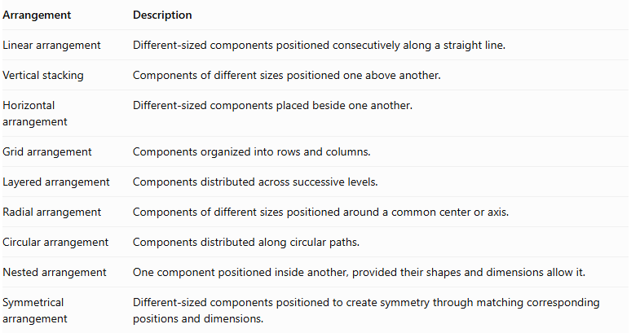
Arrangement | Description
Linear arrangement | Different-sized components positioned consecutively along a straight line.
Vertical stacking | Components of different sizes positioned one above another.
Horizontal arrangement | Different-sized components placed beside one another.
Grid arrangement | Components organized into rows and columns.
Layered arrangement | Components distributed across successive levels.
Radial arrangement | Components of different sizes positioned around a common center or axis.
Circular arrangement | Components distributed along circular paths.
Nested arrangement | One component positioned inside another, provided their shapes and dimensions allow it.
Symmetrical arrangement | Different-sized components positioned to create symmetry through matching corresponding positions and dimensions.

Mathematical Properties and Formulas

Total Volume
# Source: AI Source: Provided by: [Data Path: Persons Table -> ID Column: 1, Name_En Column: Motasem Essam] -> From: [ChatGPT] on [7/25/2026]
When components do not overlap internally, the total volume is the sum of their individual volumes.
$$\boxed{V_{total}=\sum_{i=1}^{n}{V_{i}}}$$
For $n$ components:
$$V_{total}=V_{1}+V_{2}+⋯+V_{n}$$

Total External Surface Area
# Source: AI Source: Provided by: [Data Path: Persons Table -> ID Column: 1, Name_En Column: Motasem Essam] -> From: [ChatGPT] on [7/25/2026]
The total external surface area depends on the contact regions between components.
For complete matching planar joining faces:
$$\boxed{{SA}_{total}=\sum_{i=1}^{n}{{SA}_{i}}-2\sum_{j=1}^{k}{A_{j}}}$$
Where:
- ${SA}_{i}$ = Surface area of component $i$.
- $k$ = Number of complete shared face pairs.
- $A_{j}$ = Area of shared joining face $j$.
For different-sized components, the joining faces do not always have equal areas. The formula applies when each joining pair consists of matching faces.
For partial contact, subtract the actual hidden surface regions from the sum of individual surface areas. Curved intersections require separate geometric analysis.

Total Mass
# Source: AI Source: Provided by: [Data Path: Persons Table -> ID Column: 1, Name_En Column: Motasem Essam] -> From: [ChatGPT] on [7/25/2026]
If all components have the same material density:
$$\boxed{M_{total}=ρV_{total}}$$
Where $ρ$ represents material density.
If their densities differ:
$$\boxed{M_{total}=\sum_{i=1}^{n}{ρ_{i}}}$$

Scale Factor
# Source: AI Source: Provided by: [Data Path: Persons Table -> ID Column: 1, Name_En Column: Motasem Essam] -> From: [ChatGPT] on [7/25/2026]
For proportional components:
$$\boxed{k=\frac{D_{2}}{D_{1}}}$$
Where $D_{1}$ and $D_{2}$ are corresponding linear dimensions.
For geometrically similar solids:
$$\frac{L_{2}}{L_{1}}=\frac{W_{2}}{W_{1}}=\frac{H_{2}}{H_{1}}=k$$
Their volume ratio is:
$$\boxed{\frac{V_{2}}{V_{1}}=k^{3}}$$
Their surface area ratio is:
$$\boxed{\frac{{SA}_{2}}{{SA}_{1}}=k^{2}}$$

Worked Examples

Example 1: Three Cubes with Different Side Lengths
# Source: AI Source: Provided by: [Data Path: Persons Table -> ID Column: 1, Name_En Column: Motasem Essam] -> From: [ChatGPT] on [7/25/2026]
Given:
Three cubes are joined face-to-face in a straight row.
- First cube: $s_{1}=2 cm$.
- Second cube: $s_{2}=3 cm$.
- Third cube: $s_{3}=4 cm$.
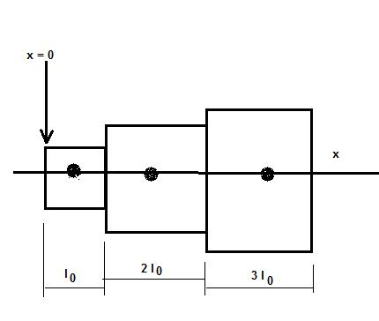
Step 1: Calculate the volume of each cube.
First cube:
$$V_{1}=2^{3}=8{ cm}^{3}$$
Second cube:
$$V_{2}=3^{3}=27{ cm}^{3}$$
Third cube:
$$V_{3}=4^{3}=64{ cm}^{3}$$
Step 2: Calculate the total volume.
$$V_{total}=8+27+64$$
$$\boxed{V_{total}=99{ cm}^{3}}$$
Step 3: Calculate the total external surface area.
Assume the cubes are joined through complete matching square regions. The first and second cubes share a $2×2$ square, and the second and third cubes share a $3×3$ square.
Individual surface areas:
$${SA}_{1}=6(2^{2})=24$$
$${SA}_{2}=6(3^{2})=54$$
$${SA}_{3}=6(4^{2})=96$$
The two contact regions have areas:
$$A_{1}=2^{2}=4$$
$$A_{2}=3^{2}=9$$
Subtract the hidden joining regions:
$${SA}_{total}=24+54+96-2(4+9)$$
$$=174-26$$
$$\boxed{{SA}_{total}=148{ cm}^{2}}$$
Important geometric note: A square face of the smaller cube can fit completely within the larger cube's face, but the larger face has an exposed surrounding region. Therefore, the contact area is the smaller square, not the entire larger face.

Example 2: Three Coaxial Cylinders with Different Dimensions
# Source: AI Source: Provided by: [Data Path: Persons Table -> ID Column: 1, Name_En Column: Motasem Essam] -> From: [ChatGPT] on [7/25/2026]
Given:
Three cylinders are stacked vertically and joined through their complete circular bases.
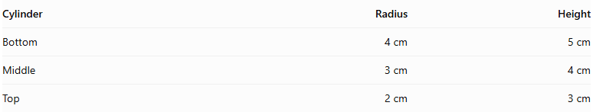
Cylinder | Radius | Height
Bottom | 4 cm | 5 cm
Middle | 3 cm | 4 cm
Top | 2 cm | 3 cm
Step 1: Calculate the volume of each cylinder.
Bottom cylinder:
$$V_{1}=π(4)^{2}(5)=80π$$
Middle cylinder:
$$V_{2}=π(3)^{2}(4)=36π$$
Top cylinder:
$$V_{3}=π(2)^{2}(3)=12π$$
Step 2: Calculate the total volume.
$$V_{total}=80π+36π+12π$$
$$\boxed{V_{total}=128π≈402.12{ cm}^{3}}$$
Step 3: Calculate the total external surface area.
Individual surface areas:
$${SA}_{1}=2π(4)(4+5)=72π$$
$${SA}_{2}=2π(3)(3+4)=42π$$
$${SA}_{3}=2π(2)(2+3)=20π$$
The shared circular joining regions have radii 3 cm and 2 cm.
$$A_{1}=9π, A_{2}=4π$$
Subtract twice the total joining area:
$${SA}_{total}=72π+42π+20π-2(9π+4π)$$
$$=134π-26π$$
$$\boxed{{SA}_{total}=108π≈339.29{ cm}^{2}}$$
The exposed annular portions of the larger cylinder bases remain part of the external surface area.
Step 4: Calculate the overall height.
$$H=5+4+3$$
$$\boxed{H=12 cm}$$

Important Characteristics
# Source: AI Source: Provided by: [Data Path: Persons Table -> ID Column: 1, Name_En Column: Motasem Essam] -> From: [ChatGPT] on [7/25/2026]
- Same geometric category: All components belong to the same geometric shape category.
- Different dimensions: At least one corresponding dimension differs between components.
- Different individual volumes: Components generally have different volumes.
- Different individual surface areas: Their surface areas may differ.
- Flexible arrangements: Components can be stacked, joined, nested, or distributed in patterns.
- Variable contact areas: Joining regions may have equal, unequal, or partially matching dimensions.
- Variable overall proportions: The final composite solid can have irregular or stepped external boundaries.
- Scalable components: Some components may be geometrically similar, while others may have non-proportional dimensions.

Comparison with Identical Components
# Source: AI Source: Provided by: [Data Path: Persons Table -> ID Column: 1, Name_En Column: Motasem Essam] -> From: [ChatGPT] on [7/25/2026]
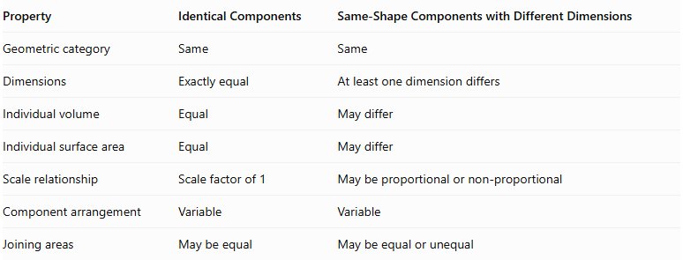
Property | Identical Components | Same-Shape Components with Different Dimensions
Geometric category | Same | Same
Dimensions | Exactly equal | At least one dimension differs
Individual volume | Equal | May differ
Individual surface area | Equal | May differ
Scale relationship | Scale factor of 1 | May be proportional or non-proportional
Component arrangement | Variable | Variable
Joining areas | May be equal | May be equal or unequal

Applications
# Source: AI Source: Provided by: [Data Path: Persons Table -> ID Column: 1, Name_En Column: Motasem Essam] -> From: [ChatGPT] on [7/25/2026]
- Architecture: Buildings made from blocks of the same shape but different sizes.
- Construction: Structures assembled from differently sized concrete blocks.
- Manufacturing: Assemblies containing cylinders or rectangular components of different dimensions.
- Mechanical engineering: Stepped shafts and assemblies made from cylindrical sections with different radii.
- Packaging: Groups of same-shaped containers with different capacities.
- Mathematics: Problems involving geometric similarity, volume, surface area, and scale factors.

Key Points
# Source: AI Source: Provided by: [Data Path: Persons Table -> ID Column: 1, Name_En Column: Motasem Essam] -> From: [ChatGPT] on [7/25/2026]
- Components have the same geometric shape but different dimensions.
- Differences may involve one dimension or several dimensions.
- Components may be proportionally or non-proportionally sized.
- Total volume is the sum of individual volumes when there is no overlap.
- Total external surface area must account for hidden joining regions.
- Different component sizes can produce stepped, tapered, or irregular composite structures.
- The classification is based on component dimensions, not their arrangement.

Conclusion
# Source: AI Source: Provided by: [Data Path: Persons Table -> ID Column: 1, Name_En Column: Motasem Essam] -> From: [ChatGPT] on [7/25/2026]
Same-shape components with different dimensions form a classification of composite solids in which every component belongs to the same geometric category, but their measurements are not identical. The components may differ in one or several dimensions, and their sizes may follow proportional or non-proportional relationships. This classification is important for understanding composite structures with variable-sized components and calculating their combined volume and external surface area.

